**CMSC203**

**Assignment 0 Part 5– JavaFX Setup**



**Installing JavaFX, Create, and run Eclipse JavaFX example**

* Install JavaFX
* Create Eclipse JavaFX example
* Compile and Run Java FX Example

**Step 1 – Java FX Installation**

**Use the following link to install JavaFX:** [**https://openjfx.io/openjfx-docs/#gradle**](https://openjfx.io/openjfx-docs/#gradle)

## JavaFX and Eclipse

This section explains how to create a JavaFX application in Eclipse. JavaFX 15.0.1 and Eclipse 2020-12 (4.18.0) were used for the IDE screenshots.

Download an appropriate JDK for your operating system and set JAVA_HOME to the JDK directory. Refer to [Install Java](https://openjfx.io/openjfx-docs/#install-java) section for more information.

Include the new JDK as Installed JREs in Eclipse -> Preferences -> Java -> Installed JREs -> Add.

You can create a JavaFX modular or non-modular project and use the IDE tools, Maven or Gradle build tools.

### **Non-modular projects**

#### **IDE**

Follow these steps to create a JavaFX non-modular project and use the IDE tools to build it and run it. Alternatively, you can download a similar project from [here](https://github.com/openjfx/samples/blob/master/IDE/Eclipse/Non-Modular/Java).

Download the appropriate [JavaFX SDK](https://gluonhq.com/products/javafx/) for your operating system and unzip it to a desired location, for instance /Users/your-user/Downloads/javafx-sdk-15.0.1.

Create a new User Library under Eclipse -> Window -> Preferences -> Java -> Build Path -> User Libraries -> New.[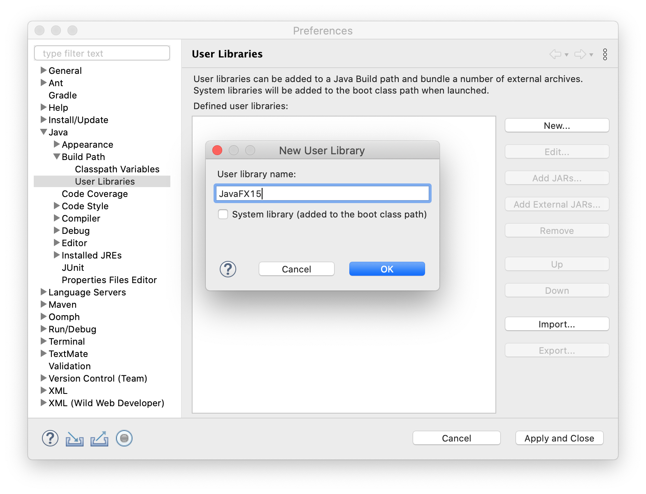](https://openjfx.io/openjfx-docs/images/ide/eclipse/ide/eclipse01.png)Name it JavaFX15 and include the jars under the lib folder from JavaFX 15.[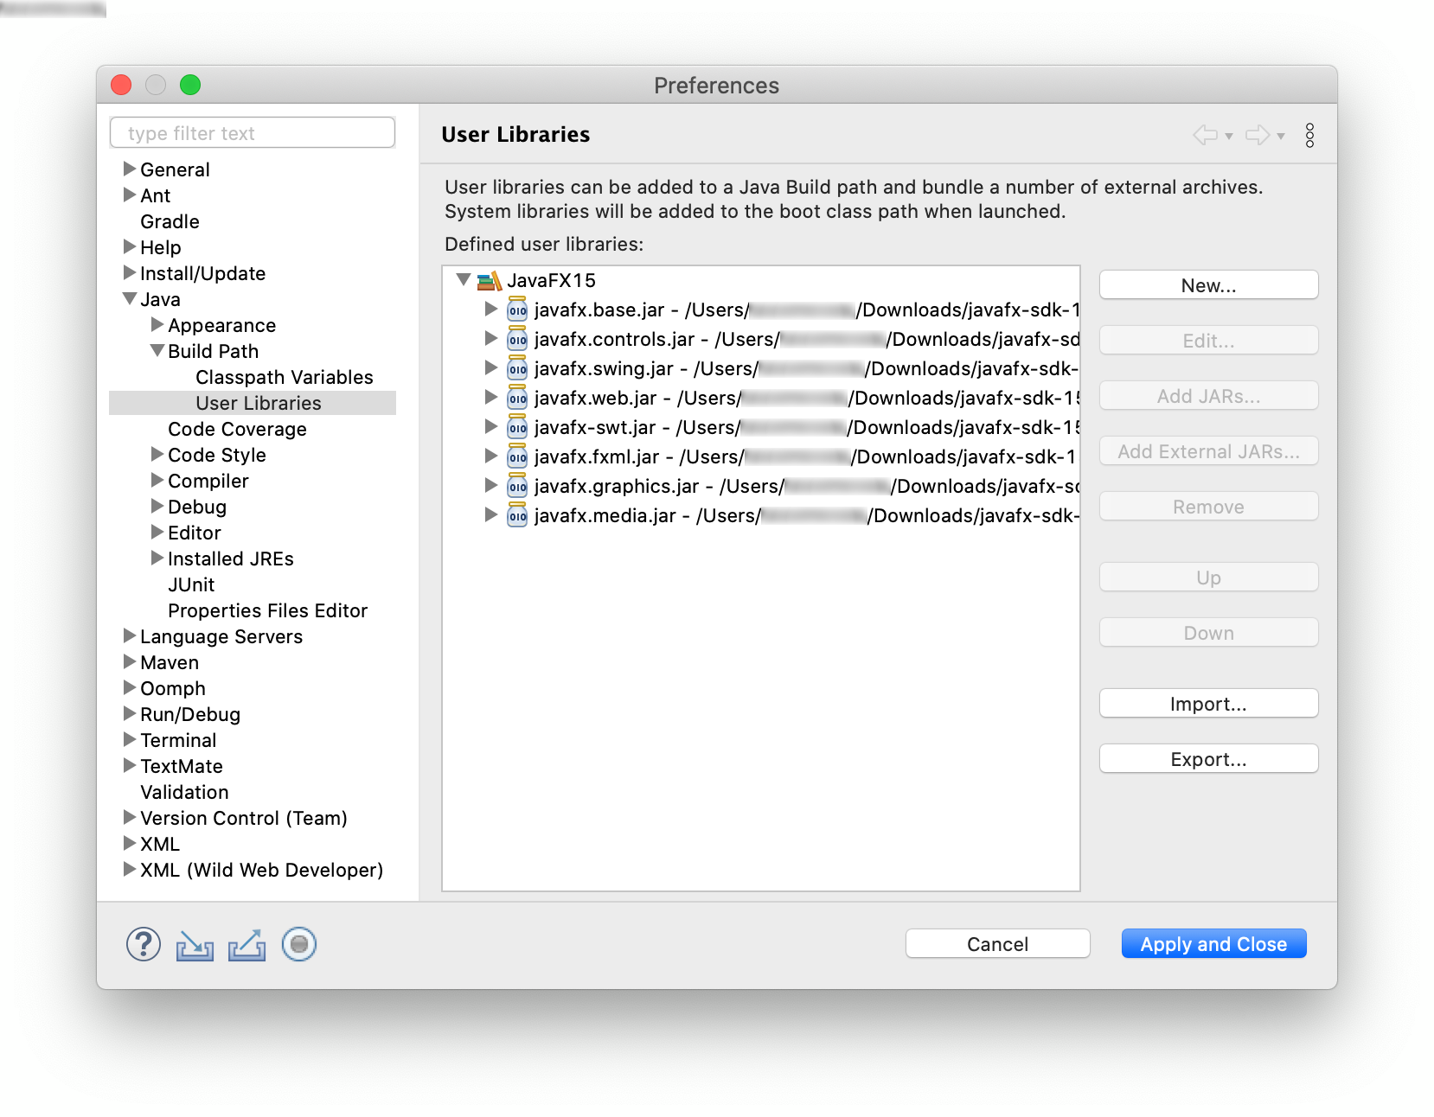](https://openjfx.io/openjfx-docs/images/ide/eclipse/ide/eclipse02.png)

##### **1. Create a Java project**

Select File -> New -> Java Project, and provide a name to the project, like HelloFX, and a location.[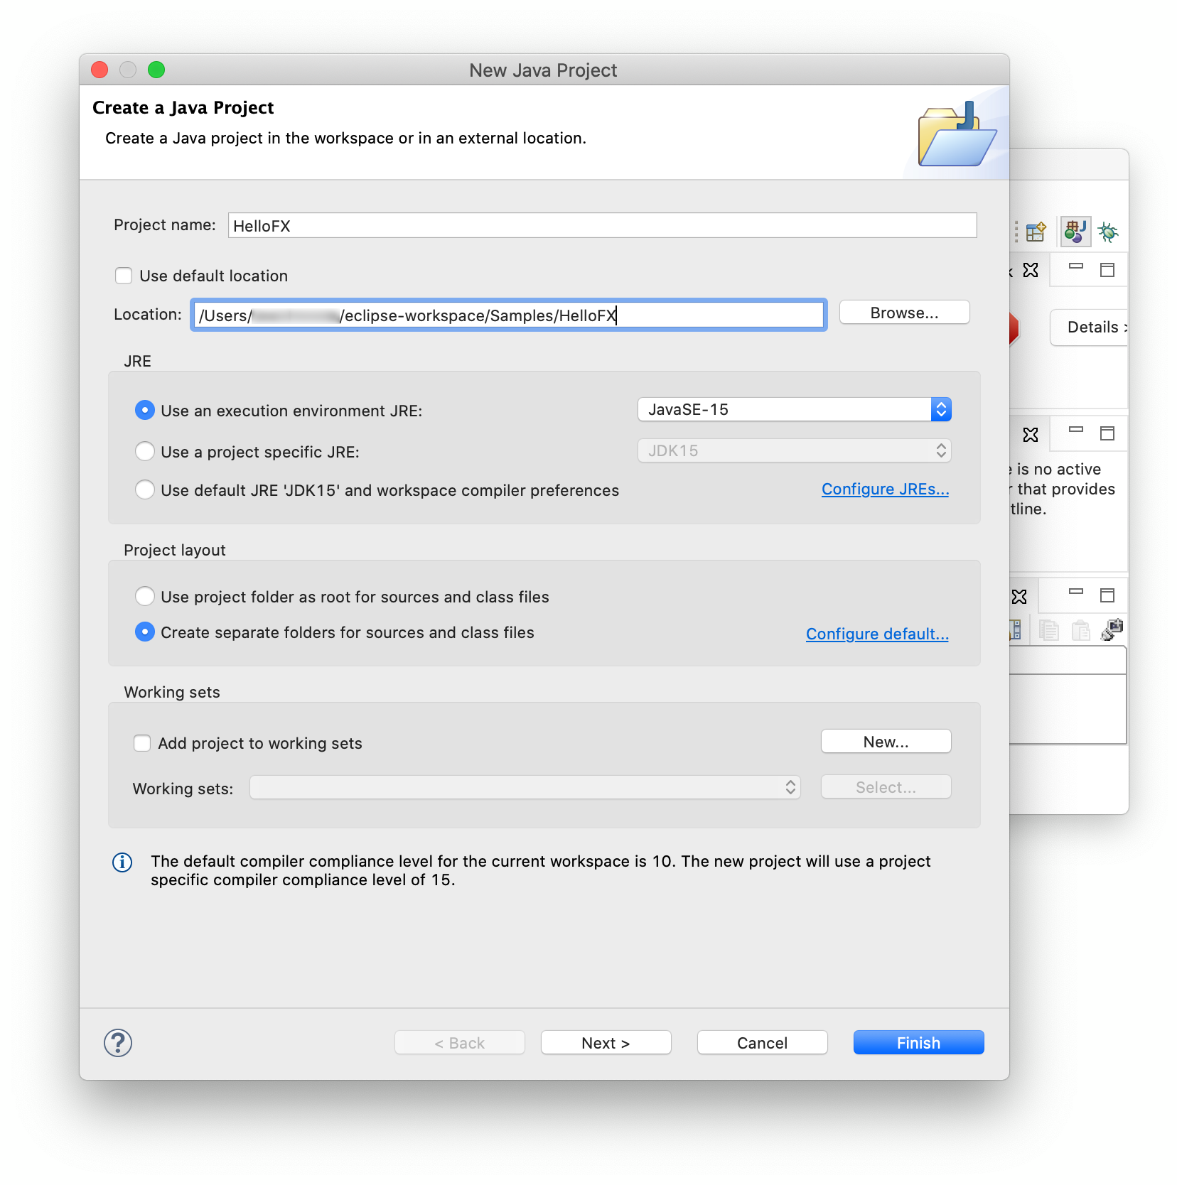](https://openjfx.io/openjfx-docs/images/ide/eclipse/ide/eclipse03.png)Make sure JDK 11 or greater is selected. You don't need to add a module-info.java file. You can include the JavaFX15.0.1 library into the classpath.[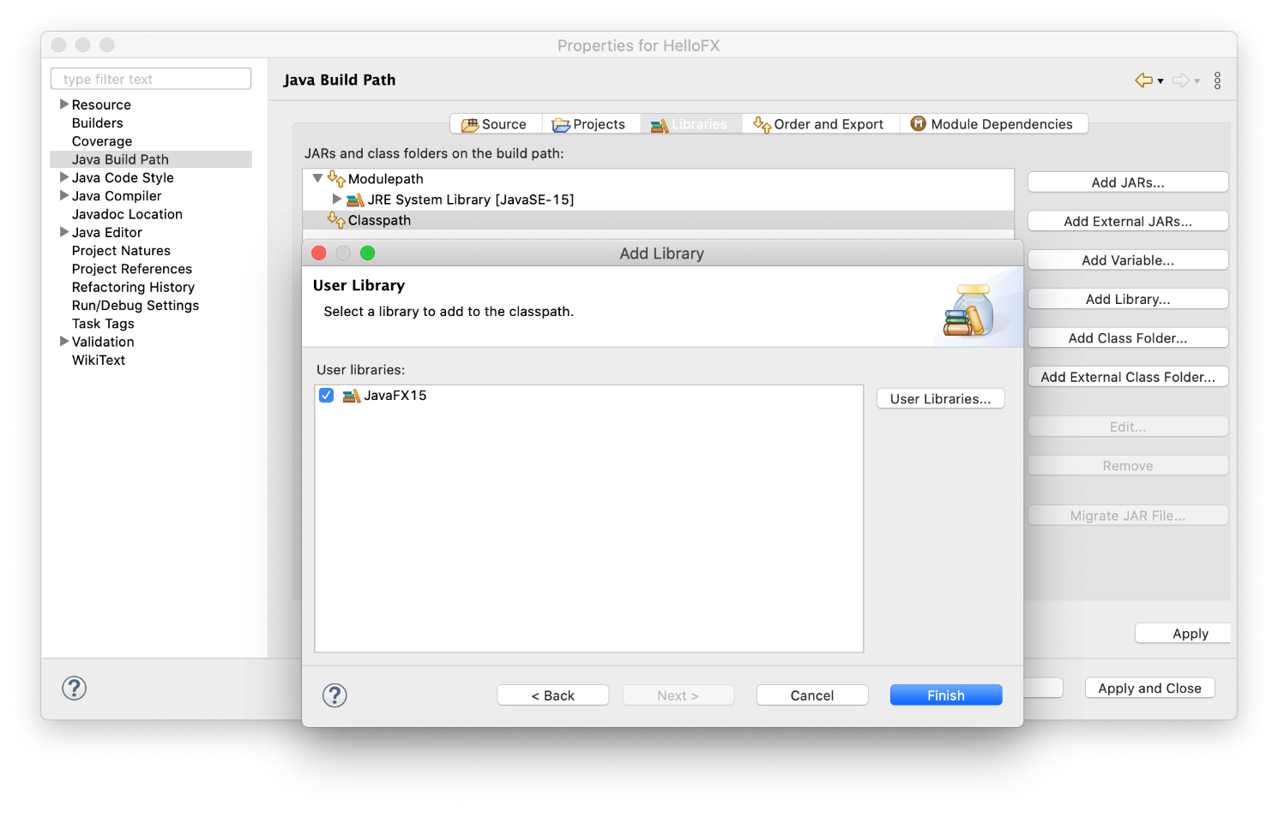](https://openjfx.io/openjfx-docs/images/ide/eclipse/ide/eclipse04.png)An empty project will be opened.

**JavaFX Example:** HelloWorldFX.java attached

import javafx.application.Application;

import javafx.event.ActionEvent;

import javafx.event.EventHandler;

import javafx.scene.Scene;

import javafx.scene.control.Button;

import javafx.scene.layout.StackPane;

import javafx.stage.Stage;

public class HelloWorld extends Application {

public static void main(String[] args) {

launch(args);

}

@Override

public void start(Stage primaryStage) {

primaryStage.setTitle("Hello World!");

Button btn = new Button();

btn.setText("Say 'Hello World'");

btn.setOnAction(new EventHandler<ActionEvent>() {

@Override

public void handle(ActionEvent event) {

System.out.println("Hello World!");

}

});

StackPane root = new StackPane();

root.getChildren().add(btn);

primaryStage.setScene(new Scene(root, 300, 250));

primaryStage.show();

}

}

**Warning:**If you now run the project it will compile but you will get this error:

Error: JavaFX runtime components are missing, and are required to run this application

This error is shown since the Java 15 launcher checks if the main class extends javafx.application.Application. If that is the case, it is required to have the javafx.graphics module on the module-path.

##### **3. Add VM arguments**

To solve the issue, click on Run -> Run Configurations... -> Java Application, create a new launch configuration for your project named `hellofx` and add these VM arguments:

* [Linux/Mac](https://openjfx.io/openjfx-docs/#nix-eclipse-non-ide-1)
* [Windows](https://openjfx.io/openjfx-docs/#win-eclipse-non-ide-1)

Linux/Mac:

--module-path /path/to/javafx-sdk-15.0.1/lib --add-modules javafx.controls,javafx.fxml

Windows:

--module-path /path/to/javafx-sdk-15.0.1/lib --add-modules=javafx.controls

Examples:

--module-path C:\Users\JavaFX_15\javafx-sdk-15.0.1\lib --add-modules=javafx.controls

**Warning:**Make sure the checkbox **"Use the -XstartOnFirstThread argument when launching with SWT"** is not checked.

[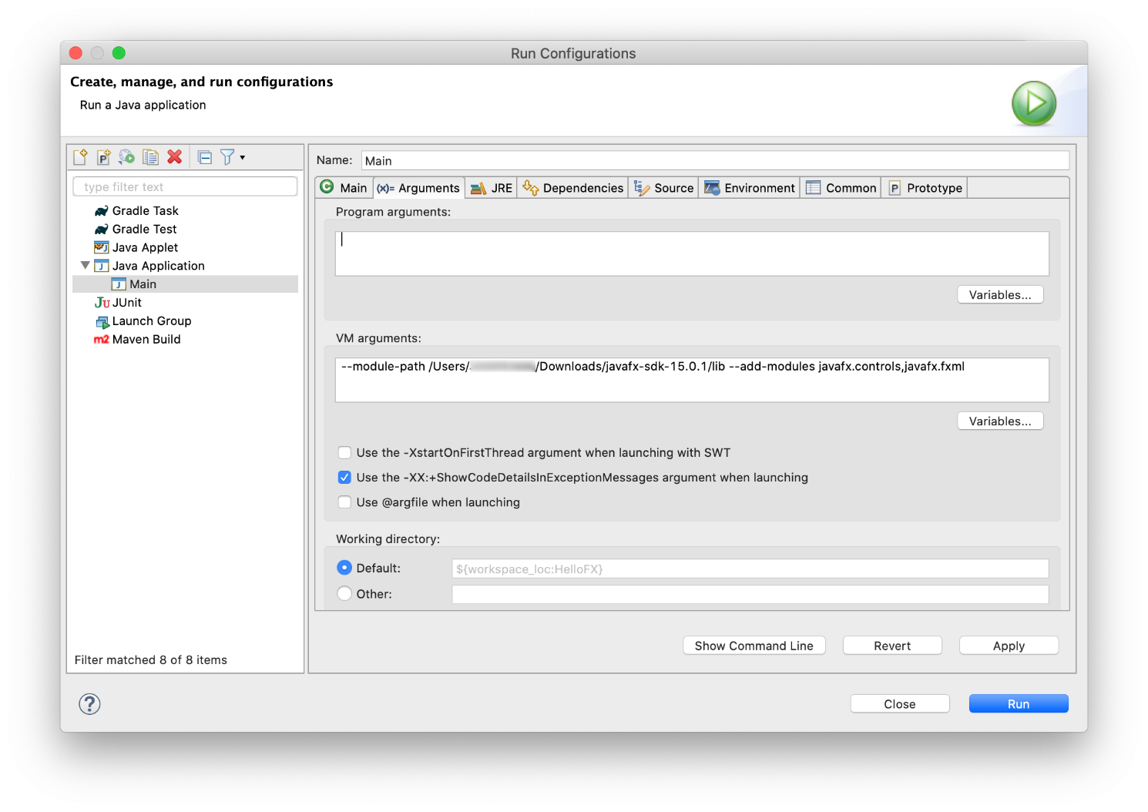](https://openjfx.io/openjfx-docs/images/ide/eclipse/ide/eclipse06.png)Click apply and close the dialog.

##### **4. Run the project**

Click Run -> Run As -> Java Application -> to run the project.

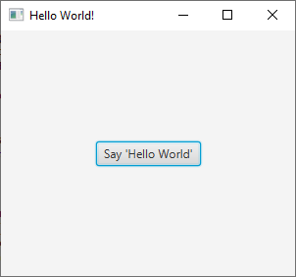

**Deliverables**

Upload the word document containing the screen shots to Blackboard.

**Submit:**

Screenshots showing:

JavaFX

* 1. Project screenshot
  2. Running example screenshot
  3. Java Source Code File

**References**

<https://openjfx.io/openjfx-docs/#gradle>